**Q1.** Write a program using C/C++ on any Linux platform, such as Ubuntu operating system, to create a child process that copy the parent address space and then make the child as a Zombie process. Use *ps* utility to demonstrate that the zombie has been created. Please note that the zombie process is usually depicted as *<defunct>* or *+Z* in Ubuntu.

**Terminal Output:**

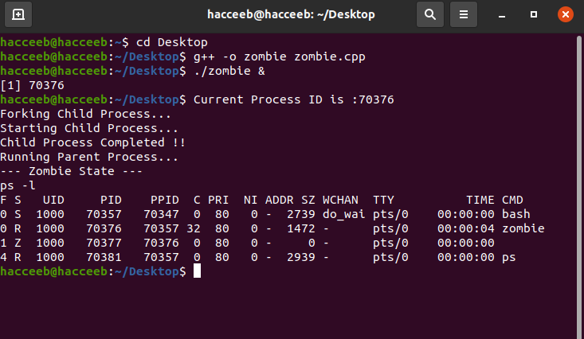

**Q2.** Use the procedure followed in Q1 to make the child process as Orphan. Using *ps* utility to show that the orphan process has been handed over to the *init, systemd* process (whose *pid* is 1) or another parent perhaps.

**Terminal Output:**

